**1.1. Introduction to digital imaging**

Machine vision may be compared to human vision taking into account the functional parameters applicable to industrial processes.

* Adaptability to environment
* Decision making
* Quality of the measurements
* Speed of response
* Spectrum response
* Two or three dimensions
* Data input/output
* Sensitivity
* Color
* Perception
* Economic considerations

Vision or image processing system may be divided into three functional components:

1. Image acquisition

2. Preprocessing

3. Classification

**1.2 Image acquisition**

Image acquisition tool transforms the visual image of a physical object and its intrinsic characteristics into a set of digitized data used for processing. It can be considered as consisting of four phases:

***1.2.1. Illumination***

a) directional illumination (for mate Lambertian surfaces where irradiance depends on the angle of the light upon the surface). It is not used for specular (mirror) surfaces.

b) diffuse illumination is good for mate and specular surfaces (does not produce the sharp shadows)

c) rear illumination for only geometrical outline of an opaque(not transparent) flat objects (is used for separation the object and background)

d), e) light and dark field illumination like the particular case of rear illumination (for light - bright background, dark object)

f) telecentric illumination conversion of the spatial radiance distribution of a light source into bundles of parallel rays that reflect the radiance of the single point of the light source. It is the source of various types of illumination.

g) Pulsed illumination reducing the blurring effects and measuring time constant synchronized with camera, for fast processes, imaging velocimetry.

h) modulated illumination with certain frequency in thermography.

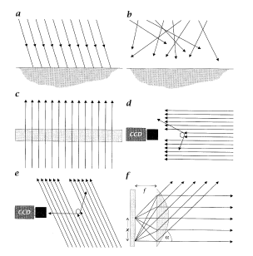

Different illumination setups: a) direct, b) diffuse, c) rear,

d) light field, e) dark field, f) telecentric illuminations

***1.2.2. Image formation or focusing***

The lens are used for focusing the images on sensing elements.

(magnification - real size), focal length, depth of field ( deviation from the surface still in focus), lens mounting

**1.2.3. Image detection or sensing**

Image formation is made on a sensor which converts the object's reflected radiation to a analog or digital signal taking into account geometrical correspondence between scene and image. It is achieved by suitable positioning of the camera with respect to the scene and by using lenses with appropriate focal distance, or of a zoom type when the vision field must be adjustable.

Usually the ***hardware set-up*** for a computer vision system consists of the following:

**system for acquiring images** (photosensitive elements, light point sensors, CCD - charge couples devices (sequential access), vacuum tube cameras, solid state MOS cameras, CID - charge injected devices (random access), CPD- Charge priming device

**Basic configurations of the addressing system:**

a) x,y addressing

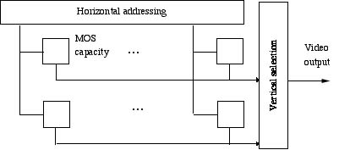

b) CCD sequential reading

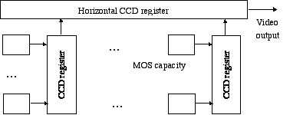

**Solid state camera performance**

|  |  |  |  |
| --- | --- | --- | --- |
| Chip type | MOS | CCD | CPD/CID |
| Sensivity (min Lux) | 10 | 3 | 5 |
| Dynamic range(relative) | 1(poorest) | 4 | 1 |
| Noise | good | poor | good |
| Dark current | 15 | 1 | 4 |

***1.2.4. Formatting camera output signal***

The basic element is a digitizer. (A/D converters - data corresponding to the value for the illumination of each pixel on each line, as a function of the conversion frequency)

The sequence of operation for formation of the camera output signal is:

a) Analog signal must be sampled (obtaining of the instantaneous value of the signal at the time instant called sampling point.

b) The value of sample must be quantified to appropriate gray level

c) Quantified values must be digitized

European standard sweep time is 64m s

American standard 63.7m s

The frequency of 4 MHz is required to obtain 256 pixels per line and one of 8 MHz to get 512 pixels

**1.3 Image processing**

There are many image processing applications and problems. The basis classification may be presented as a set of classes:

**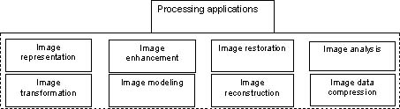**

In image representation one is concerning with characterization of the quantity that each picture-element (called pixel or pel) represents. Image models give a logical or quantitative description of the properties of this function.

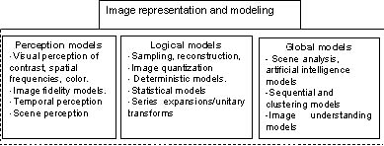

**1.4 Image perception**

***1.4.1. Color systems and chromaticity diagrams***

There are color, grayscale and binary digitizers. Binary digitizer is a particular case of two levels image representation eliminating undesired effects like weak shadow and reflections. This is good for applications such as to get direct information on stains ("spots"), impurities cracks, porosities and so on.

Color, in the abstract, is relatively simple. But real difficulties arise from what is required to adopt the color system in an optimum way to display and print devices, for transmission by television signals, or to correct for the uneven color resolution of the human visual system.

Color representation is based on the classical theory of Thomas Young where any color can be reproduced by mixing and appropriate set of three primary colors (the best spectra of human retina detection). That is apparent in the chromaticity diagrams of simple color spaces (intensity vs hue-saturation).

***a) Laws of color matching***

(i) Any color can be matched by mixing at most three colored lights (we can always find three primary sources)

(ii) The luminance of a color mixture is equal to the sum of the luminances o their components

(iii) The human eye cannot resolve the components of a color mixture (cannot resolve wavelength from a color)

(iv) Color addition: If a color C1 matches color C2 and a color C'1 matches color C'2, then the mixture of C1 and C'1 matches the mixture C2 and C'2. Using the notation:

[C1]=[C2]Þ color C1 matches color C2

1 [C1]+ 2[C2]Þ a mixture containing an amount 1 of C1 and an amount 2 of C2

we can write the preceding law as follows:

if [C1]=[C'1] and [C2]=[C'2] then

1 [C1]+ 2[C2] = 1 [C'1]+ 2[C'2]

(v) Color subtraction: If a mixture of C1 and C2 matches a mixture of C'1 and C'2 , and if C2 matches C'2 then C1 matches C'1 , if

[C1]+ [C2] = [C'1]+ [C'2] and [C2]=[C'2] then [C1]=[C'1].

(vi) Transitive law: If C1 matches C2 and if C2 matches C3 , then C1 matches C3 , i.e., if

[C1]=[C2] and [C2]=[C3] then [C1]=[C3]

(vii) Color matches: Three types of color matches are defined:

 [C] = 1 [C1] + 2 [C2]+ 3 [C3]: i.e. ,  units of C are matched by a mixture of 1 units of C1 , 2 units of C2 , and 3 units of C3. This is direct match.

Indirect matches are defined by the following:

[C] + [C1] = [C2] + [C3]

C] + [C1] +[C2] =[C3] .

These are also called Grassman's laws. They hold except when the luminance levels are very high or very low. These are also useful in color reproduction colorimetry, the science of measuring color quantitatively.

***b) Chromaticity RGB and CMYB diagram*** (luminance (intensity) is used for description of colors)

The color of image is defined by radiation intensity levels corresponding to the three main wavelengths (primary colors: red - 700 nm, green - 546.1nm, and blue - 435.8nm) presented by three normalized magnitudes:

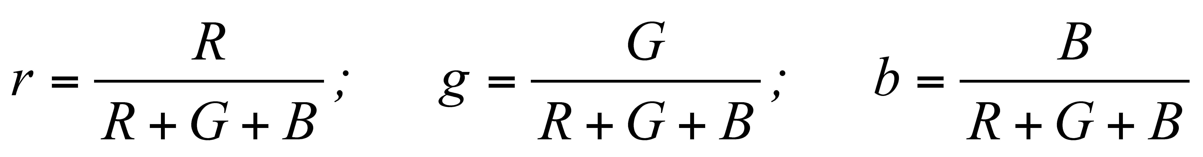

such as *r + g + b=1.* This enable us to represent the colors in a two-dimensional chromatic diagram since *b = 1 - r - g*

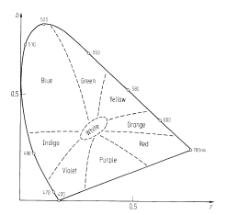

Chromatic RGB diagram from the components blue and red. U-shaped curve of monochromatic colors

with wavelength in nm as it indicated by bottom "purple" line includes all possible colors

RGB colors with the maximum intensity gives the white color. In printing industry the four color standard is used CMYB (cyan, magenta, yellow colors which gives the black color). The CMYB system is considered as additive or subtractive color based system.

A color image Ic(x,y) has RGB representation as ***Ic(x,)= [Ir(x,y), Ig(x,y), Ib(x,y)],***

where the color primaries are red, green, and blue. All colors are obtained from these three primaries as it shown in RGB cube.

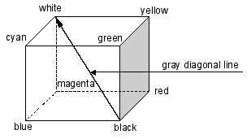

From the color primaries, the secondaries are generated as yellow equals equal parts of red and green,

cyan equals equal parts of blue and green, magenta equals equal parts of blue and red.

Equal parts of red, green, and blue yield gray, shown as the diagonal from zero intensity (black) to maximum intensity (white)

***c) Hue and saturation diagram*** *(*type of the color (hue) and the purity of the color (saturation) is used for description of color)

Hue and saturation can be extracted from chromaticity diagrams by simple coordinate transformations taking the essential "*white"* point in the middle of the chromatic diagram.

The "white" point is given in the *rg* chromatic diagram marked with *r* and *b* by

*w point = (1/3, 1/3)*. A color system that has its center at the white point is called a *color difference system*. Now, Hue-Saturation system is used a polar coordinates: radius coordinate is proportional to the saturation (mixing with white) and the hue to the angle coordinate

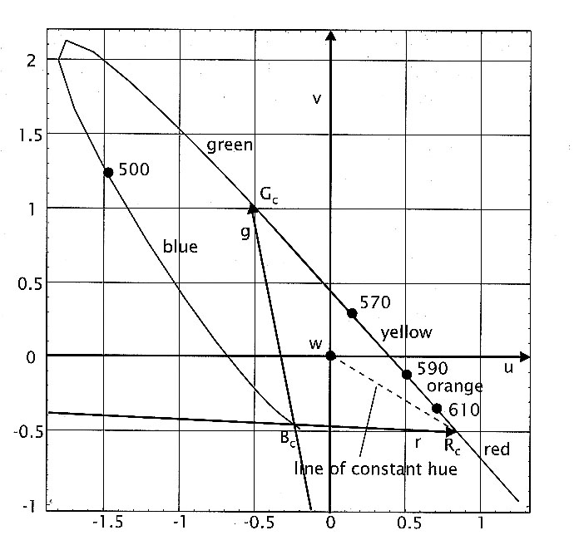

Chromaticity diagram shown in the *uv* color difference system centered

at the white point *w*. The color saturation is proportional to the distance

from the center and the color hue is given by the angle.

The color Hue-Saturation coordinate system is optimally suited to present vector image information and includes three parameters simultaneously: Intensity, Hue, and Saturation (IHS). (the gray scale image needs one parameter only).

This representation is known as the IHS color coordinate system. The transformation is given by:

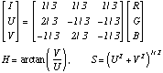

This transformation essentially means that the zero point in the chromaticity diagram has shifted to the white point. The pairs [U,V]\*and [S,H]\* are the Cartesian and polar coordinates respectively.

IHS color space may be presented in polar coordinate system, red corresponds to 0º, green to 120º, and blue to 240º.

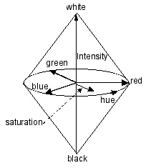

Intensity is shown on the vertical axis from black to white.

Hue is represented angularly: red at 0º. Green at 120º, and blue at 240º.

Saturation is represented as the radial distance from origin, 0 for no saturation (gray) and 1 for fully saturated color.

The chromaticity diagram has a following properties:

1. The locus (position) of all the points representing spectral colors contains the region of all visible colors (first quadrant - positive coefficients),

2. The straight line joining the coordinates of blue (360 nm) and red (780nm) contains the purple colors and is called the line of purples.

3. The region bounded by the straight lines joining the coordinates (0,0), (0,1) and (1,0) (almost first quadrant) contains all the colors reproducible by the primary sources. This region is called color gamut of the primary sources.

4. The reference white of the CIE (Commission Internationale de L'Eclairage, the International committee on colors standards) primary system has chromaticity coordinates (1/3,1/3). Colors lying close to this point are the less saturated colors. Colors located far from this point are the more saturated colors. Thus the spectral colors and colors on the line of purples are maximally saturated.

***d) Color Coordinate Systems***

There are several color coordinate systems which have come into existence for a variety of reasons. The CIE spectral primary sources do not yield a full gamut of reproducible colors ( really there are not practical set of three primaries for production of that all colors). Therefore the XYZ coordinate system is appeared as hypothetical (primary sources are physically unrealizable) primary sources are positive for any color. White is the color with X=Y=Z=1.

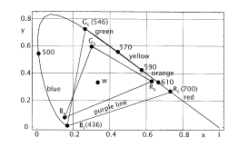

Chromaticity diagram for the CIE XYZ color coordinate system

(all the positive coefficient of primary colors). Y represent luminance of the color.

The Uniform chromaticity scale (UCS) system u,v,Y is related to XYZ system where Y is luminance and u an v are chromaticity coordinates. This system is useful for measuring color differences quantitatively.

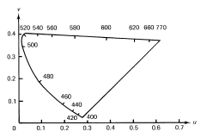

Chromaticity diagram for the CIE UCS color coordinate system

The National Television System Committee (NTSC) receiver primary system (RN, GN,BN was developed for television receivers (such as RN=GN=BN=1).

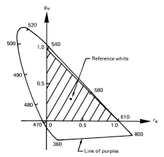

Chromaticity diagram for the NTSC receiver primary system.

(reference white for NTSC is different from that for the CIE system)

The NTSC transmission system (Y,I,Q) was developed to facilitate transmission of color images using the existing monochrome television channel without increasing the bandwidth requirement. The Y is the luminance and the other two tristimulus signals I and Q represent Hue and Saturation of the color and whose bandwidth are much smaller than that of the luminance signal.

**Color coordinate system transformation**

|  |  |
| --- | --- |
| **Color coordinate system** | **Description** |
| 1. CIE spectral primary system : R, G, B | Monochromatic primary sources : red = 700nm, green = 546.2 nm, blue = 435,8 nm. Reference white - R=G=B=1. |
| 2. CIE X,Y,Z system. Y-luminance | C:\Documents and Settings\khec\Desktop\chap3\1.4_files\Image148.gif |
| 3. CIE UCS system: u, v, Y. Y-luminance, u,v, - chromaticities, ( z=1-x-y) | C:\Documents and Settings\khec\Desktop\chap3\1.4_files\Image149.gif |
| 4. NTSC receiver primary system RN,GN,BN | C:\Documents and Settings\khec\Desktop\chap3\1.4_files\Image14_10.gif |
| 5. NTSC transmission system. Y-luminance,  I,Q - chrominances | Y=0.299RN+0.587GN+0.114BN  I=0.596RN-0.274GN-0.322BN  Q=0.211RN-0.523GN+0.312BN |

***1.4.2. Temporal properties of vision***

Temporal aspects of visual perception become important in the processing of the motion images or video streams.

***Bloch's Law:*** Light flashes of different duration but equal energy is indistinguishable below a critical duration. This critical duration is about 30 ms when the eye is adapted at moderate illumination level. The more time the eye is adapted to the dark, the longer is the critical duration.

When a slowly flashing light is observed, the individual flashes are distinguishable. At the flashing rates above the critical fusion frequency (CFF does not exceed 50-60Hz), the flashes are indistinguishable from a steady light of the same average intensity.

Thus the interlaced image fields are sampled and displayed at rate of CFF (60 frames/s) to avoid any flicker perception.

For detailed treatment of color vision, it is important to refer to the

- Committee on Colorimetry, Optical Society of America. The science of color. Opt. Society of America, Washington, 1953.

- Pratt W. Digital image processing, Wiley, New York, 1991.

-Inglis A.F. Video engineering. McGraw-Hill, Ney York, 1993.

- Anil K. Jain, Fundamentals of Digital Image Processing, Prentice Hall, NJ., 1989.

- Garlbiati L., Machine Vision and Digital Image Processing Fundamentals, Prentice Hall, NJ, 1990.

***1.4.3. Simultaneous******contrast***

The luminance or intensity of an object is independent of the luminances of the surrounding objects. The brightness (also called apparent brightness) of an object is the perceived luminance and depends on the luminance of the surround. Visual phenomena: *Two objects with different surroundings could have identical luminance but different brightness.* Our perception is sensitive to luminance contrast rather than the absolute luminance values.

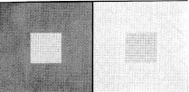

Simultaneous contrast: small squares in the middle have equal luminance

but do not appear equally bright.

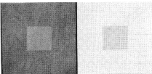

Simultaneous contrast: small squares in the middle appear almost equally bright,

but their luminances are different.

According to Weber's law : if the luminance *f0* of an object is just noticeably different from the luminance *fs* of its surround, then their ratio is

C:\Documents and Settings\khec\Desktop\chap3\1.4_files\Image14_13.gif

Writing *f0 = f , fs + f* where * f* is small for just noticeably different luminances, previous equation can be shown as

C:\Documents and Settings\khec\Desktop\chap3\1.4_files\Image14_14.gif

The value of the constant has been found experimentally to be *0.02*, which means that at least *50* levels are needed for the contrast on the scale of *0* to *1*. Previous equation says equal increment in the log of the luminance should be perceived to be equally different, i.e. * (log f) is proportional to  c,* the changes in contrast. Accordingly, the quantity : *c=a1 + a2 log10 f* where *a1 , a2* are constants, is called the contrast.

There are other models of contrast **" Luminance to Contrast Models"**

|  |  |  |
| --- | --- | --- |
| 1 | Logarithmic law | c=50log10f, 1  f  100 |
| 2 | Power law | *[C:\Documents and Settings\khec\Desktop\chap3\1.4_files\eq2.jpg](http://ict.udlap.mx/people/oleg/docencia/IMAGENES/eq)*, n=2,3,..., 2 = 10,  3 = 21.9 |
| 3 | Background law | C:\Documents and Settings\khec\Desktop\chap3\1.4_files\Image14_15.giffB background luminance |

The luminance *f* usually lies in the interval *[0,100]* except in the logarithmic law. Contrast scale is over *[0,100]*.

***1.4.4. Much Bands***

The spatial interaction of luminances from an object and its surround creates a phenomenon called the *Much band effect*. This effect shows that brightness is not a monotonic function of luminance. Consider the gray level bar chart with constant luminance within each bar. Transition an each bar appear BRIGHTER on the right side and DARKER on the left side (it is shown by dashed line with undershoots and overshoots which illustrate the Much band effect)

  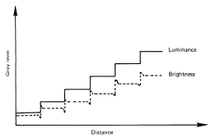

Gray-level bar chart and Much band effect.

***1.4.5. Image fidelity criteria***

Image fidelity criteria are useful for measuring image quality and for rating the performance of a processing technique or a vision system. There are two types of criteria that are used for evaluation of image quality, subjective and quantitative.

**a)** **Subjective criteria** uses the rating scales such as goodness scales and impairment scale. The training set of images is used to calibrate such scale. The group goodness scale is based on comparison within a set of images.

**Image goodness scales**

|  |  |
| --- | --- |
| **Overall goodness scale** | **Group goodness scale** |
| Excellent (5) | Best (7) |
| Good (4) | Well above average (6) |
| Fair (3) | Slightly above average (5) |
| Poor (2) | Average (4) |
| Unsatisfactory (1) | Slightly below average (3) |
|  | Well below average (2) |
|  | Worst (1) |

The numbers in parenthesis indicate a numerical weight attached to the rating.

**b) There is an *impairment scale*** which rates an image on the basis of the level of DEGRADATION present in an image when compared with an ideal image.(useful in applications such as image coding, restoration, projection...)

**Impairment scale**

|  |  |
| --- | --- |
| Not noticeable | 1 |
| Just noticeable | 2 |
| Definitely noticeable but only slight impairment | 3 |
| Impairment not objectionable | 4 |
| Somewhat objectionable | 5 |
| Definitely objectionable | 6 |
| Extremely objectionable | 7 |

**c) Among the quantitative measures,** a class of criteria used often is calls the *mean square criterion*. It refers to some sort of average or sum (or integral) of squares of the error between two images. For *MxN* images *u(m,n)* and *u'(m,n)*, (or *v(x,y)* and *v'(x,y)* in the continuous case ), the quantity:

C:\Documents and Settings\khec\Desktop\chap3\1.4_files\Image14_18.gif

where *R* is the region over which the image is given, is called the *average least squares* (or i*ntegral square*) *error*

**1. 5 Fundamental concepts of image processing**

***Pixel.*** The image will be described by an *NxM* matrix of pixel values ( the elements *p(j,j)* are nonnegative scalars), that indicates the light intensity of the flux on the picture element at (*x,y*) represented by the pixel as it shown in the figure.

*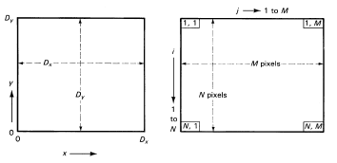*

Relationship of picture elements a) and corresponding pixel distribution in matrix b)

The origin in the picture and matrix is different: the *x* and *y* coordinates in the picture start at the lower left corner, whereas the numbering of pixels starts at the upper left corner of the matrix.

*i =x* where *1 i  N\* j = (M-y) 1 j  M\**

*(*\*some programs use *(0,0)* instead of *(1,1)* for the first location)

Increment step: *x = Dx / N y = Dy / M*

The numerical value or magnitude of the pixel indicates the average light intensity on the picture element area represented by a pixel.

*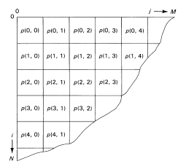*

Pixel indexing in image matrix

The value of the pixel *P(i,j)* in binary representation ranges from 0 to1. For example, the dark area taken as a pixel area is zero if there is no illumination , and 1 if there is maximum illumination

*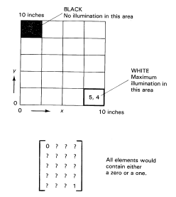*

Non-uniform lighting on the surface and

resulting image pixel values defined by matrix.

The area of pixel can be rectangular or circular with or without overlapping. ( there are areas which are not measured, or measures twice))

*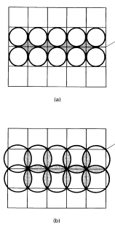*

Nonrectangular areas represented by pixel:

round non-overlapping a) and round overlapping b)

***Gray scale***

In order to provide information on intervening values of illumination, the number of bits representing the pixel value must be increased.

number of bits for pixel = log102 (number of scale levels)

*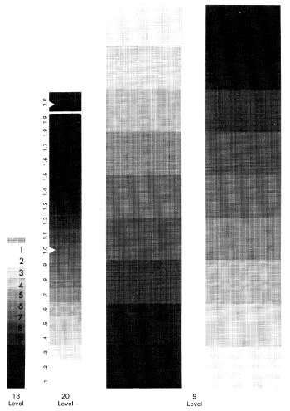*

Sample gray scales

For definition of the pixel's value the area of the dark region is calculated. (introduction of the quantization errors due to non-integer value of estimated dark area)

*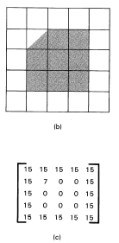*

*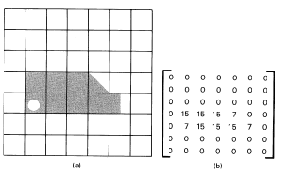*

Irregular shaped objects on light table with corresponding image pixel values.

***Histogram*** is the graphical presentation on the frequency count of the occurance of each intensity (gray level) in an image. The histogram is constructed by:

* Digitizing the image
* Counting the pixels at each gray scale level
* Plotting the frequency count of pixels at each gray level.

Histogram can be considered to be collection of bar graphs where

*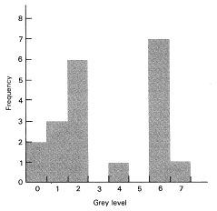*

Histogram for eight gray levels in four by five array image

(x-the values of the gray levels, y - the number of pixels having that gray level)

The probability of a pixel value *b* occurring at a given point *(x,y)* in the previous picture is calculated

*P(b)* at any point *(x,y)* = *(value b) / ( total number of pixels)*

For example, if the gray level is *b=6* and value of the occurrence for this level is *7*, therefore *P(6) =7/20=0.35*

Histogram provides the frequency of occurrences of pixels with the same level but NO information about the location of the pixel. Histogram for a specific image is unique. Sharp diagram indicates a lack of contrast. Histograms provide information on equalizing two images for subtraction purposes.

.

**1.6. Sources of image distortion**

During the image acquiring and digitizing both steps (getting the electrical signals through the sensor by suitable optical system and problems of quantization process) are the sources of image distortion.

The correct interpretation of image is limited by:

*- geometrical distortions* due to relative position of the sensor and the scene (deformation proper to perspective)

*- distortion due to used lighting system* (shadows or reflections)

*- loss of information* due to the fact that the image obtained is generally a two-dimensional projection of the three dimensional scene (occlusions or ambiguities which require intelligent interpretation based on the context)

***1.6.1. Geometrical distortion***

It may be caused by the perspective resulting from the positioning of the camera with respect to the scene and the parameters of the lens used; usually corrected through computation.

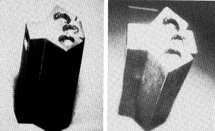

*Geometrical distortion due to perspective*

***1.6.2. Distortion of moving images due to sweep***

This type of distortion appears in vacuum tube due to interlacing, in line-by-line scanning by a progressive shift of some parts of image. A sweep of even and odd lines in successive frames introduces the distortion depended on the difference of duration of the sweeps of the frame. (solving - reducing the exposure times less than 1/1000s)

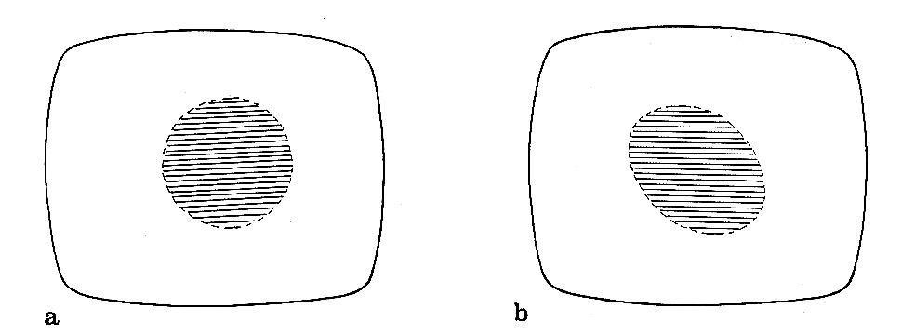

Distortion in images of moving objects caused by the image sweep.

a) image of a fixed object b) image of the object while moving

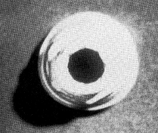

Distortion in images of moving objects obtained with a camera with interlacing sweep

***1.6.3. Shadows***

The distortions due to the lighting system can basically three different effects:

***- The introduction of the false information*** (projection of shadows which are interpreted as differential areas of the object or invariant with the rotation, for example, to the symmetric position of the elements causing the projected shadow)

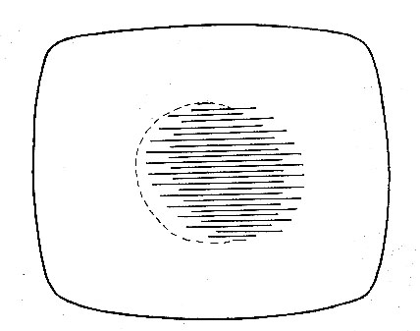

Distortion caused by shadows invariant with the rotation

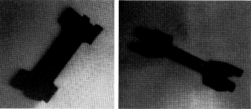

Distortion caused by shadows sensitive to the orientation

***- Dimensional distortion*** is the result of the project of the shadow on the scene plane that may leads to shift of the limits between the object and background altering the observed geometric magnitudes.

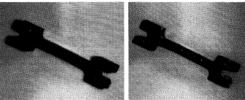

Dimensional distortion caused by the shadow

***- The concealing of information*** is another effect that shadow projected on the objects in the scene. It consists of hiding information relevant to their recognition (grooves, holes, joins, edges, and so on).

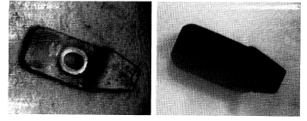

Occlusion by shadows of relevant characteristics of an object

**1.7. Loss of information**

due to different causes which affect various domains:

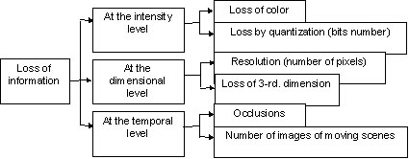

***- Loss of information at the intensity level*** is divided into two cases:

a) Loss of color information does not affect the dimensional characteristics but sometimes can lead to wrong interpretation weak distinguishing characteristics.

b) Loss by quantization is due to a limited resolution of light intensities for each point to a limited number of gray levels

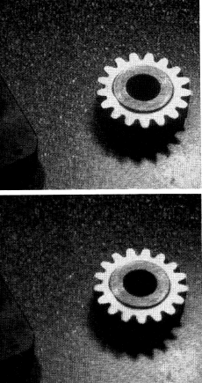

Digitalized image with different

numbers of gray levels a) resolution of 6 bits b) resolution of 4 bits.

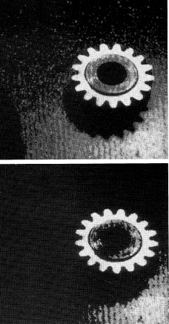

Resolution of three bits and two bits

***- Loss of information at the dimensional level*** is presented by:

a) *Resolution* (The digitalization of an image for storage requires not only quantization in gray levels but also a spatial sampling. The sampling frequency results from a compromise between the reduction of the frequency spectrum of signal and the volume of resulting information = resolution)

b) *Frame limitations* (The framing limits the visible area of the scene and is given by the geometric parameters of the lens employed)

c) Loss of the third dimension (Usually, the 2D image has enough information to interpret the 3-rd dimension but not in all case it is efficient)

d) Partial concealment (masking) of objects ((when the object contained in a scene are partially hidden. May be concealment by overlapping in 2D scenes and concealment of part of three-dimensional object due to its relative position with respect to camera)

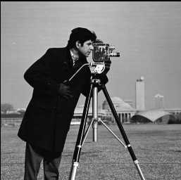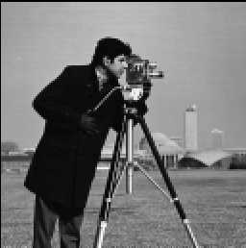

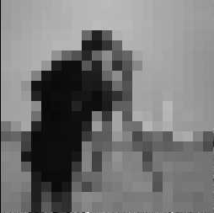

Image digitized with different level of resolution

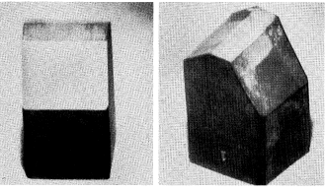

Occlusions in three- dimensional images a) front view b) lateral view.

***- Loss of information at the dimensional level*** ( in dynamic scenes due to sweep, displacement, rotation, occlusions...)